**Tutorial 16: Click Event Modifiers**

When we are using click events, we may want to modify when and how we react to them. Examples could be wanting the user to react to a right click instead of the normal left click or perhaps we could want the user to hold down a specific key like holding down the shift key. In our case we want the user to be able click on a specific div tag instead of the child div tag. Event modifiers allow us to modify how the click event is registere and when we react to them.

Here are some examples:

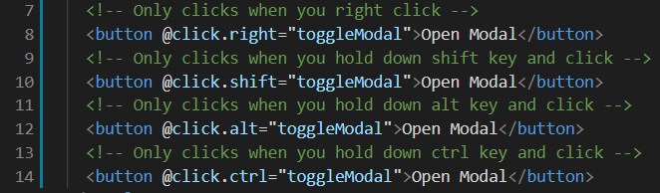

Make sure **Tutorial 15** is complete to be able to move on to this tutorial or clone the [vue3-firebase-course](https://github.com/younggrasshopperza/vue3-firebase-course) repository and go to branch called **Tutorial-15**.

**Step 1:** In the Modal.vue file, on the click event add the event modifier self.

Look at the example below (**Line 3**):

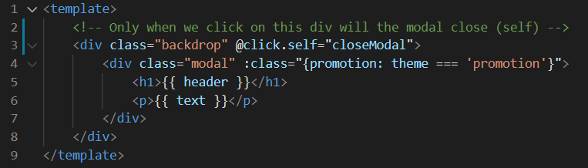

If you try to click the red modal the modal should still appear but if you click outside of the modal, the modal should be gone. Make sure to hard refresh if it does not work.

**Output:**

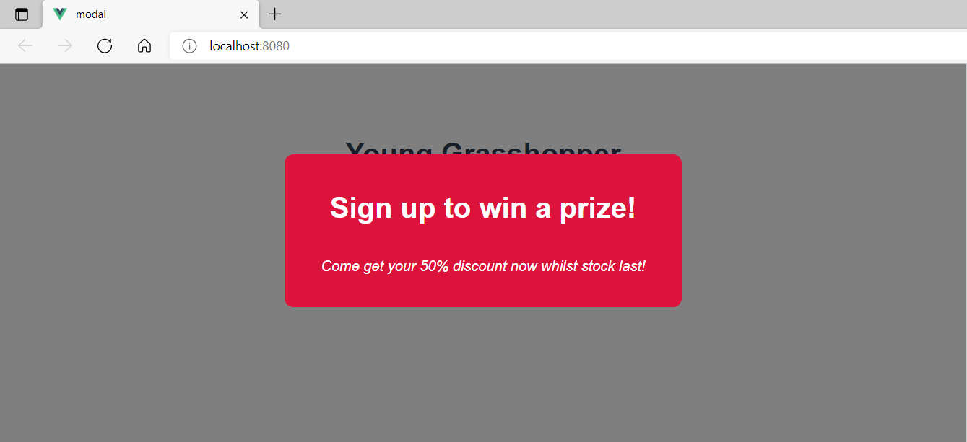

**You can view the code snippets from the** [**vue3-firebase-course**](https://github.com/younggrasshopperza/vue3-firebase-course) **repository under the Tutorial-16 branch**.